SE-4112 Software Quality Engineering  
Ms. Hira Asim  
Fall 2021

**Muhammad Sohaib Assignment 3**

**F2018065227 Section: w1**

**BLACK BOX TESTING**

**Name of the Application:**

Rozee.pk

**Category:**

Web Application

**Short Description:**

It’s a job finding website in Pakistan. The skilled and experienced people upload their cv to get the job and also the companies. ROZEE.PK is Pakistan's number one online job site which connects talent with opportunity. ROZEE.PK provides services to the job seekers and employers by providing them one platform for job searching and hiring, respectively.

**Equivalence Class Partitioning (ECP):**

**Feature:**

Uploading the CV.

In the CV module, we upload the only 1 cv. The minimum is 0 and the maximum is 2.

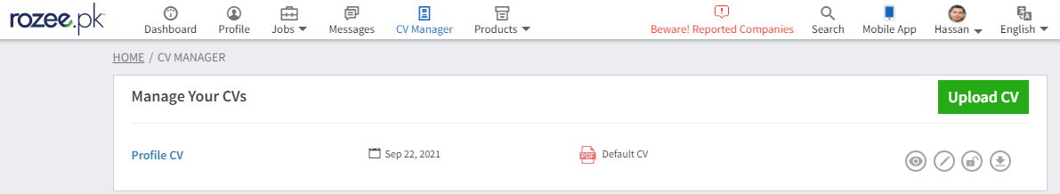

|  |  |  |
| --- | --- | --- |
| Invalid | Valid | Invalid |
| <=0 | 1 | >=2 |

Boundary Value Analysis (BVA)

**Feature:**

Uploading the CV

As we take the above module and example of ECP of the uploading the CV. And the maximum CV is 1. So, we have the boundary range and we fix that according to that.

Valid Boundary condition is: 1

Invalid Boundary condition: 0 2

1 2

0 1

Boundary

Boundary

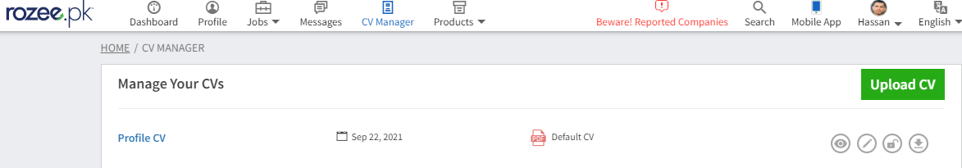

Decision Table Testing (DTT)

**Feature:**

Login.

We are doing DTT on Login module of the Rozee.pk Application.Here are the business rules.

1. On putting ID & Password, user should be able to login successfully.
2. User is not allowed to login successfully if any or both ID & Password are empty or incorrect and show the error message.

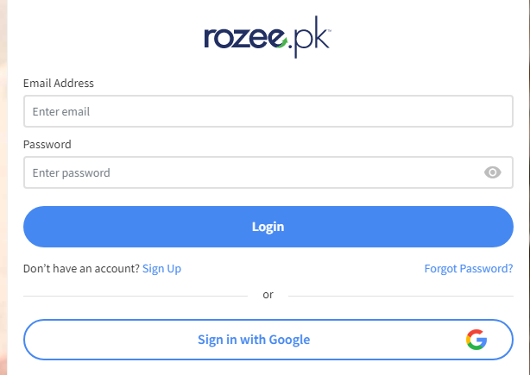

|  |  |  |  |  |  |  |  |  |  |
| --- | --- | --- | --- | --- | --- | --- | --- | --- | --- |
| Decision Table | Rule 1 | Rule 2 | Rule 3 | Rule 4 | Rule 5 | Rule 6 | Rule 7 | Rule 8 | Rule 9 |
| Conditions | TC01 | TC02 | TC03 | TC04 | TC05 | TC06 | TC07 | TC08 | TC09 |
| User-ID | Valid | Empty | Invalid | Empty | Invalid | Empty | Valid | Invalid | Valid |
| Password | Valid | Empty | Empty | Valid | Valid | Invalid | Empty | Invalid | Invalid |
| Actions |  |  |  |  |  |  |  |  |  |
| Login Successfully | Execute |  |  |  |  |  |  |  |  |
| Error |  | Execute | Execute | Execute | Execute | Execute | Execute | Execute | Execute |

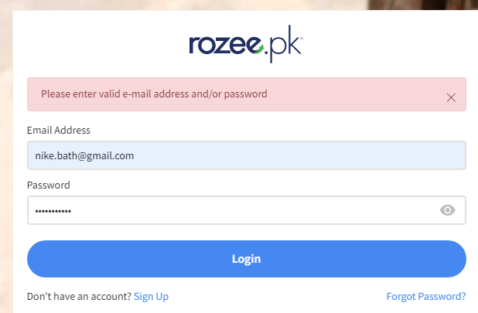

State Transition Testing (STT)

**Feature:**

Sign Up.

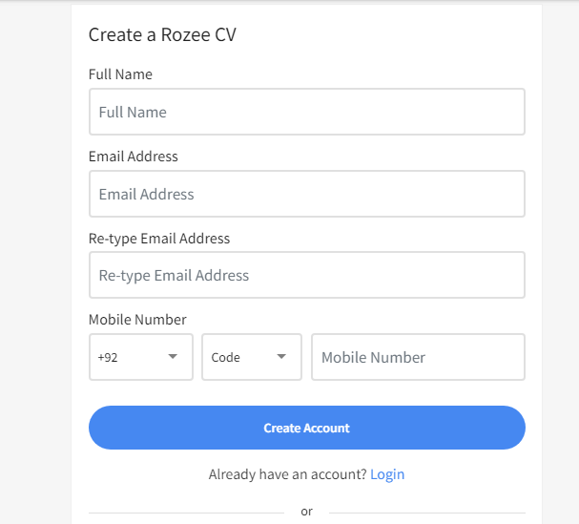

|  |  |  |
| --- | --- | --- |
|  | Correct Info | Incorrect Info |
| D1) Sign Up | D5 | D2 |
| D2) 1st try | D5 | D3 |
| D3) 2nd try | D5 | D4 |
| D4) 3rd try | D5 | D6 |
| D5) Go to Booking module | - | - |
| D6) Again Ask for Another try | - | - |

**Error Guessing Testing:**

Suppose there is a requirement stating that the mobile number should be numeric and not less than 10 characters. And, the software application has a mobile no. field.

Now, below are the Error Guessing technique:

* What will be the result if the mobile no. is left blank?
* What will be the result if any character other than a numeral is entered?
* What will be the result if less than 10 numerals are entered?

**Another Example:**

Suppose there is a requirement stating that email should be in email format([abc@gmail.com](mailto:abc@gmail.com)) and the application has email field.

Now, below are the Error Guessing technique:

* What will be the result if the email is left blank?
* What will be the result if any character other than a format is entered?

